**Experiment No:1**

**Title:** Installation and Configuration of virtualization

**Aim:** To understand the concepts of virtualization and implementation of it.

**Theory**:

**Virtualization:**

Virtualization is the "creation of a virtual (rather than actual) version of something, such as a server, a desktop, a storage device, an operating system or network resources".

In other words, Virtualization is a technique, which allows to share a single physical instance of a resource or an application among multiple customers and organizations. It does by assigning a logical name to a physical storage and providing a pointer to that physical resource when demanded.

Creation of a virtual machine over existing operating system and hardware is known as Hardware Virtualization. A Virtual machine provides an environment that is logically separated from the underlying hardware.

The machine on which the virtual machine is going to create is known as Host Machine and that virtual machine is referred as a Guest Machine

Types of Virtualizations:

* Hardware Virtualization.
* Operating system Virtualization.
* Server Virtualization.
* Storage Virtualization.

**1) Hardware Virtualization:**

When the virtual machine software or virtual machine manager (VMM) is directly installed on the hardware system is known as hardware virtualization.

The main job of hypervisor is to control and monitoring the processor, memory and other hardware resources.

After virtualization of hardware system, we can install different operating system on it and run different applications on those OS.

Usage:

Hardware virtualization is mainly done for the server platforms, because controlling virtual machines is much easier than controlling a physical server.

**2) Operating System Virtualization:**

When the virtual machine software or virtual machine manager (VMM) is installed on the Host operating system instead of directly on the hardware system is known as operating system virtualization.

Usage:

Operating System Virtualization is mainly used for testing the applications on different platforms of OS.

**3) Server Virtualization:**

When the virtual machine software or virtual machine manager (VMM) is directly installed on the Server system is known as server virtualization.

Usage:

Server virtualization is done because a single physical server can be divided into multiple servers on the demand basis and for balancing the load.

**4) Storage Virtualization:**

Storage virtualization is the process of grouping the physical storage from multiple network storage devices so that it looks like a single storage device.

Storage virtualization is also implemented by using software applications.

Usage:

Storage virtualization is mainly done for back-up and recovery purposes.

**Virtualization Tool:**

**VirtualBox**

VirtualBox is open-source software for virtualizing the x86 computing architecture. It acts as a hypervisor, creating a VM (virtual machine) where the user can run another OS (operating system).

The operating system where VirtualBox runs is called the "host" OS. The operating system running in the VM is called the "guest" OS. VirtualBox supports Windows, Linux, or macOS as its host OS.

When configuring a virtual machine, the user can specify how many CPU cores, and how much RAM and disk space should be devoted to the VM. When the VM is running, it can be "paused." System execution is frozen at that moment in time, and the user can resume using it later.

**Practical:**

Downloading Oracle VirtualBox:

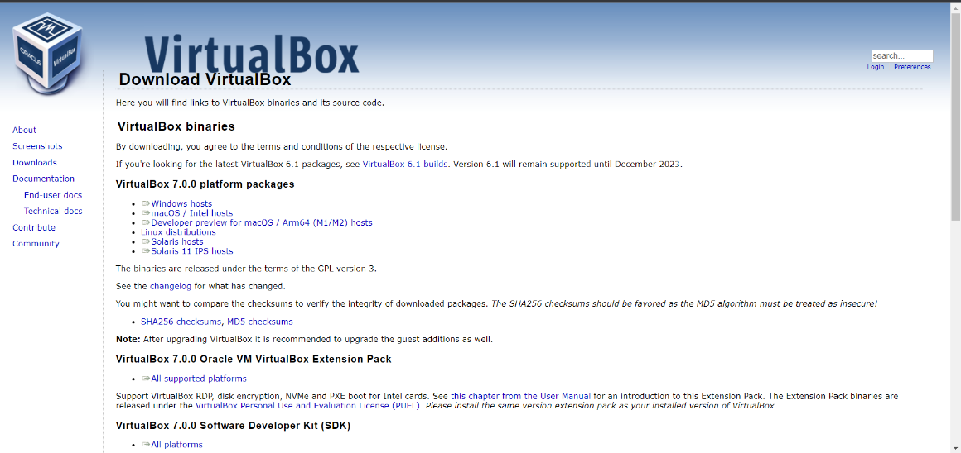

Installation:

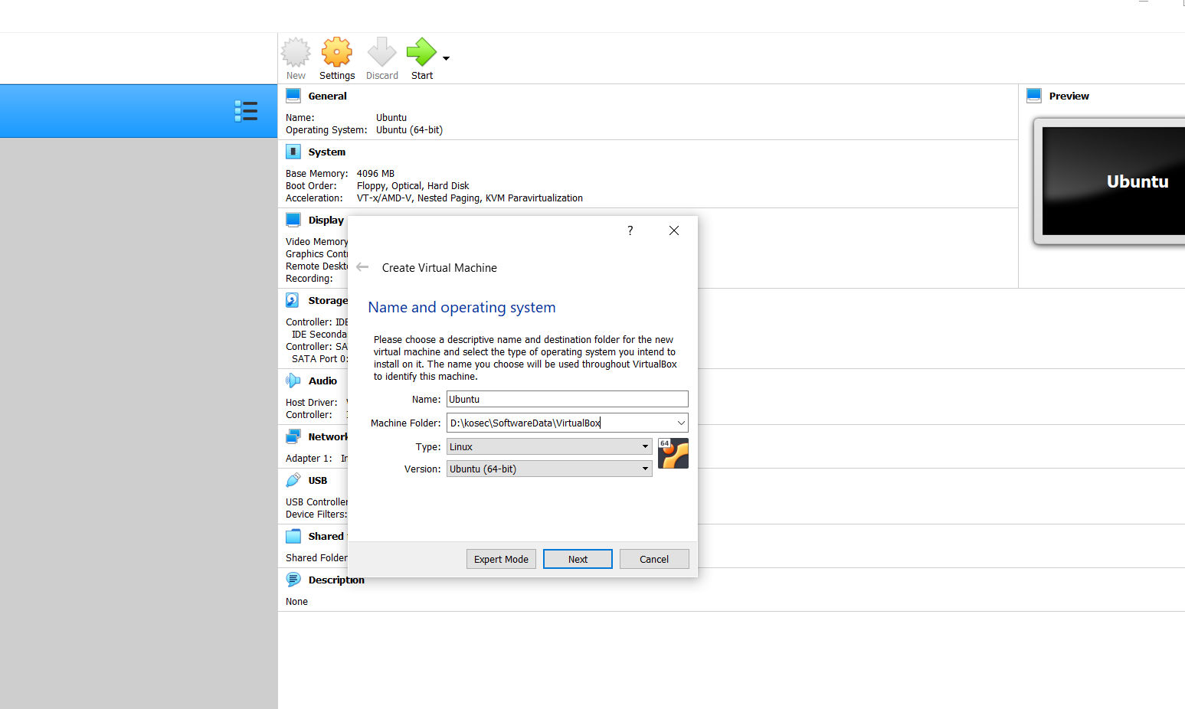

Configuration of Virtual Machine:

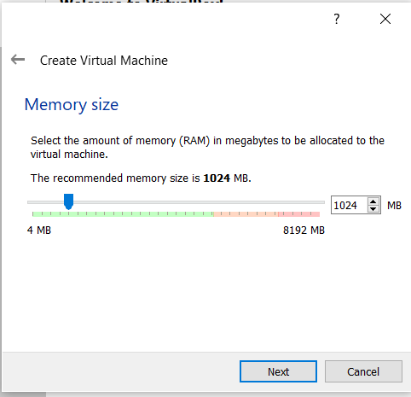

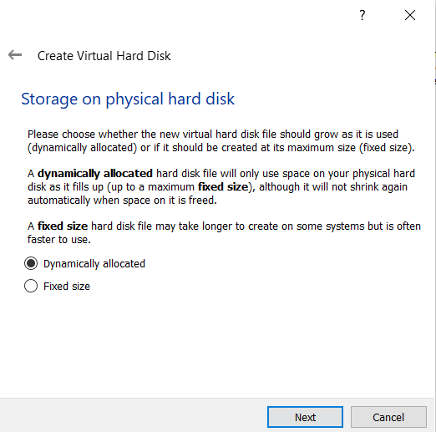Configure

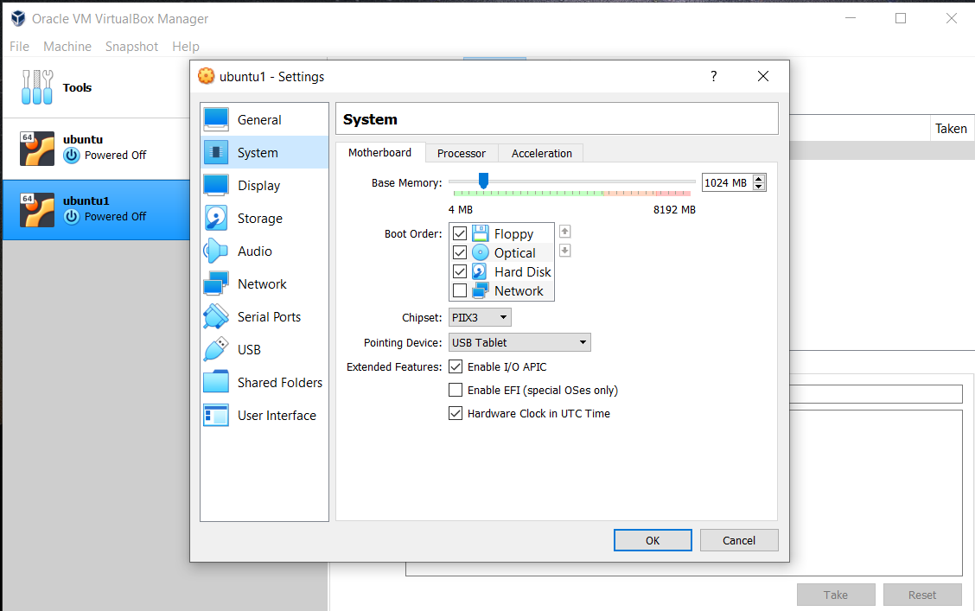

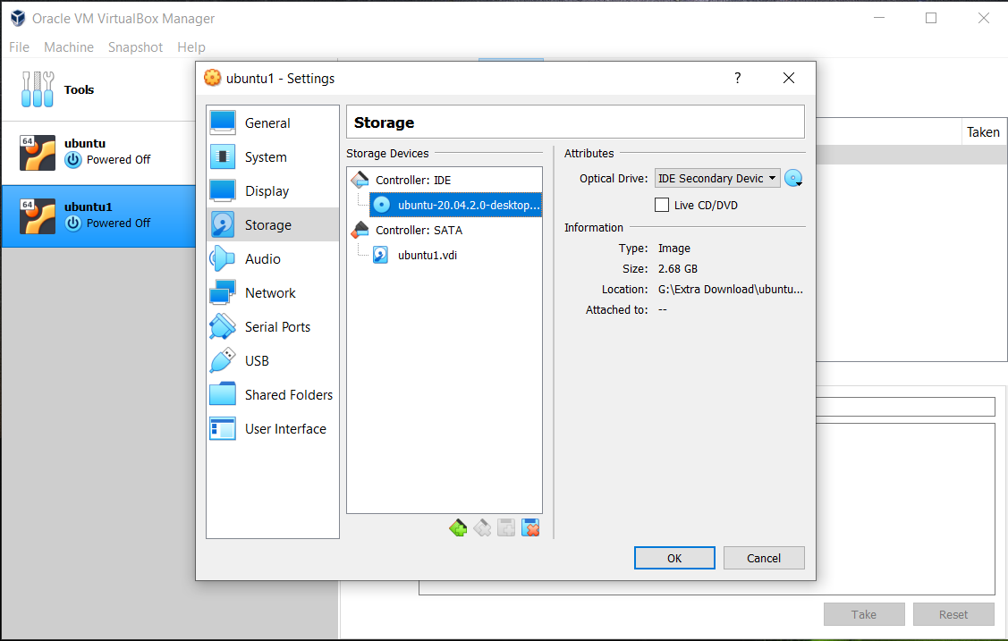

Running Virtual Machine:

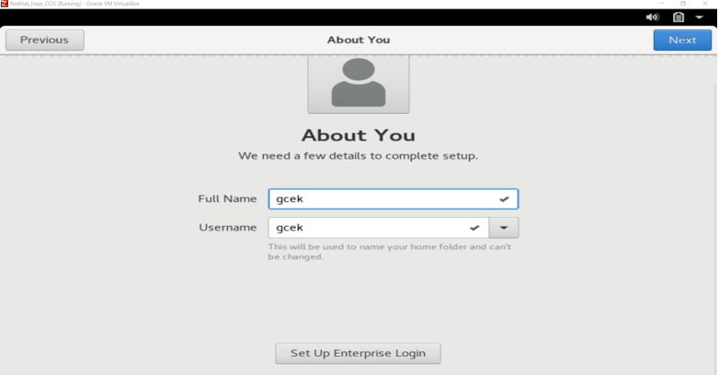

**Conclusion:**

Thus, we have performed installation and configuration of Virtualization.